

  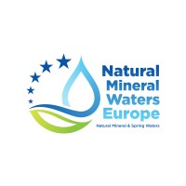

### Brussels, May 2025

**ANNEX I: Register of designated representative**

The designated representatives acknowledge and accepts the applicable rules and conditions set forth in the non-disclosure agreement between PETCORE, UNESDA and NMWE.

|  |  |
| --- | --- |
| **Name** | **Delegation** |
| Argiris Dabanlis | **General Secretary** |
| Kostas Papamargaritis (Polisan) | **PETCORE EUROPE** |
| Luca Stamare (Corepla) |
| Andreas Christel (Polymetrix) |
| Robert Siegl (ALPLA) |
| Diego Lugagne (Coca-Cola) | **UNESDA** |
| Maarten Geerse (Suntory) |
| Jean-Francois Briois (Nestlé) | **NMWE** |
| Anne - Flore Jacob (Danone) |